Reflective Journal

Student name: **Joey Tatú - 15015556**

Programme: **BSc (Hons) in Computing – Software Development**

Month: **October 2019 (Week 3 – 7)**

# My Achievements

## Week 3 (30/09):

I was sick this week, so I didn’t get anything done.

Week 4:  
Monday:

I worked on the Project Proposal today. I took parts of it from my Project Proposal last year. I emailed Eamon and Paul to ask them if references were needed. I assume they are.

I also worked on the Lab from Week 3 in Data Application Development. Tomorrow and Thursday, I want to do research on the technologies for websites dealing with appointments. I think Java and SQL will be sufficient, but if I can find something better, that world be good too.

### Tuesday, Wednesday and Thursday:

I worked on the Data Application Development (DAD) labs, as well as doing tutorials on Python. I felt Python isn’t fully explored in the DAD module, so I decided to get a head start while I could.

### Friday:

Friday was a bad day for me, mental health wise and I didn’t do anything. I try to keep my weekends free.

## Week 5 (07/10):

### Monday:

**09:10 –** Talked with my supervisor, Paul Stynes about my project. He reviewed my video again and discussed with me about the idea. He said that the idea is similar to a bricks and mortar store where everything is done manually, but he suggested looking at Google Scholar and looking for automation and delving deeper into the Artificial Intelligence part of the project.

**09:30 –** Paul did a seminar about Software Requirements.

1. Use Cases. Actor -> Use Case
2. NO! Use Case to Actor
3. Use Cases to Use Cases
4. 4 to 6 Use Cases.
5. Functional Decomposition is Actor -> Use Case -> Actor. (If it gets big – NO)

**10:00 –** I have been looking at the link Paul provided and I am understanding the general concept. What I have provided is a brick and mortar scenario where the tattooist (etc) and the client are doing things manually. And I want to automate this process. But the question remains; “how do I do that?” Seemingly with my project idea last year and this year, I seem to go for something complicated and not really discussed in a scholar environment. It’s a little bit frustrating.

From: <https://pdfs.semanticscholar.org/65a6/7db9ba8992b27bfda0a134afa1397e2c8af7.pdf> :

“In-store Technologies in the Retail Servicescape”.

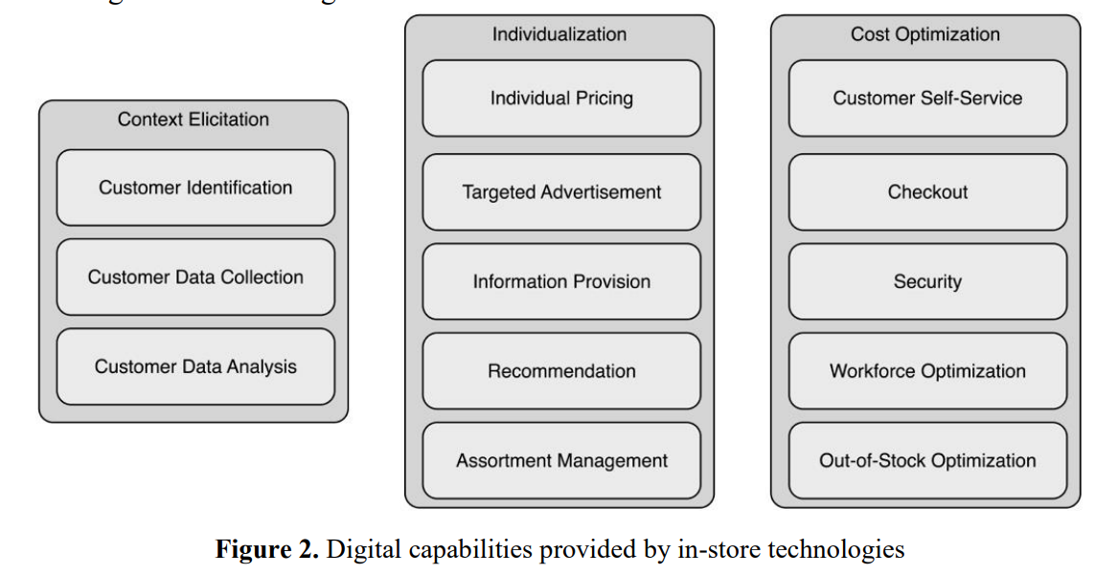

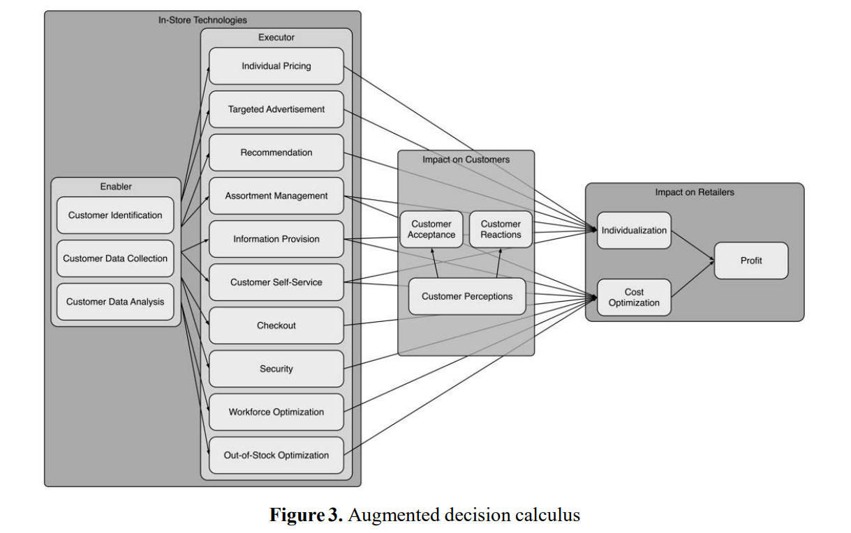

I was thinking of how I could do something similar but change it for body modification’s artists and clients. It makes sense to me.

# My Reflection

Example text

# Intended Changes

Example Text

# Supervisor Meetings

**Date of Meeting: 14/10/19 – 09:10 – 09:25**

Items discussed: Paul discussed my Project Pitch Video. He discussed the general idea of my project.

Action Items: Paul suggested to look at Google Scholar and look for automated bookings and payments, along with delving right down into the Artificial Intelligence part. It is assumed my project is approved.

Links provided: <https://scholar.google.com/scholar?as_ylo=2018&q=automating+a+bricks+and+mortar+store&hl=en&as_sdt=0,5>

**Date of Meeting: 14/10/19 – 11:15 –**

Items discussed:

Action Items:

Links provided:

|  |  |  |
| --- | --- | --- |
| **Student Signature:** | ____________________________ | Date: ____/____/2019 |
|  | JOEY TATÚ |  |
|  |  |  |
|  |  |  |
|  |  |  |
| **Supervisor’s Signature:** | ____________________________ | Date: ____/____/2019 |
|  | PAUL STYNES |  |